

Welcome to Nursery! We are looking forward to having lots of fun and making new friends.

This information pack will give you some details about activities and events your child will be involved in.

Meet the staff!

******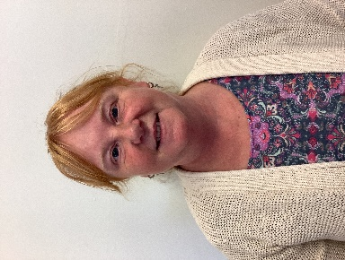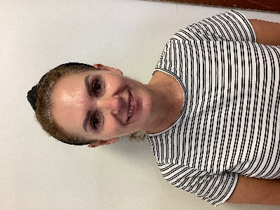**

Mrs Evans

Nursery Lead

Mrs James

Nursery Lead

Mrs Jeffs

TA

Mrs Hier

TA

**Where to go**

Please bring your child to the gate closest to the crossing patrol person. Staff will be there to greet you and take the children down to the classroom. Your child will then place coat/bag on their peg, find their name to self-register and get then join in playing with friends.

**Timings**

Morning Nursery- 9.00-11.30am

Afternoon Nursery 12.30-3pm (To be confirmed)

**What will your child need?**

Please provide a suitable coat. Dependent on the weather; warm hat on cold days, sun hat, suncream during the Summertime.

A bag with a change of clothes, (top, bottoms, underwear, socks) wipes, and a carrier bag is also handy for messy play and any toileting accidents. We have changing facilities and if needed staff will support children to change.

**Toileting**

Our bathroom facilities are all child sized and caters for a range of needs. If you have any concerns or worries please do not hesitate to speak to one of the Nursery Leads.

**Lets get moving!**

Every **Thursday** the children will be involved in a physical activity session. It would be beneficial if the children could wear leggings/joggers. They will be taking their shoes off and moving bare foot. (When time allows, please practise taking shoes and socks on and off)

**Wellie Wednesday!**

Every **Wednesday** the children will have the opportunity to go outside and enjoy playing in the woods. The children may get a little dirty! Please could you send in a pair of Wellingtons and if possible a waterproof all in one that we can keep in school. Even though we will be in the woods every Wednesday, we might pop out for a splash on other occassions!

**Snack time**

Fruit and other healthy snacks are served every day. The cost for snacks is £1 per week which is payable once a half term.

This payment includes the cost of golden time and cooking. As a school, we are currently in the process of setting up an online payment system, which will be used for paying for snack time etc. In the meantime, we kindly ask you to send cash in the envelope provided. Further information will follow.

**Uniform**

We do our very best to keep the children clean and tidy, providing aprons and using water-based paints. Please see the children’s uniform as ‘workwear’ and sometimes they will come home a bit messy!

Uniform with the school badge can be purchased from Sew and sew embroidery [www.sewandsew.online](http://www.sewandsew.online). Although it is not compulsory, and uniform can be bought from clothes shops/supermarkets.

**Please label all clothes/coats/bags with your child’s name.**

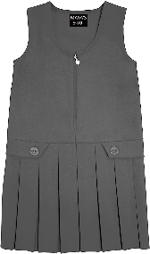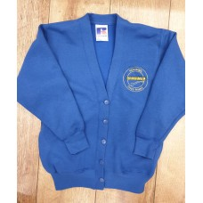

**Water bottles**

Children are encouraged to bring a drink of water to school. We will have a box in class they can place their drink and help themselves throughout the day. Please label the bottle with their name.

**Reading**

Sharing stories at home is invaluable to your child’s overall development. Singing songs, nursery rhymes and spending time talking together will have a positive impact.

We will be having a library session on a Thursday, where you and your child to choose a book from our class library.

**Wellcomm**

This is a scheme we use to assess the children’s language development. It quickly identifies areas of concern in language, communication, and interaction development to ensure early targeted intervention is in place. Staff plan play based activities and if there is anything, you can do at home

to help we will let you know.

**Medical information**

If your child suffers with any medical conditions, please let us know. It is very important that we have everything in place to keep them safe and well.

If you are concerned about anything, please phone the school 01792 892337or email us [penyrheolprimaryschool@penyrheol-pri.swansea.sch.uk](mailto:penyrheolprimaryschool@penyrheol-pri.swansea.sch.uk)