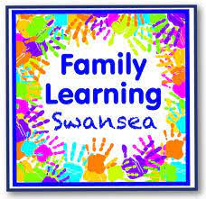

Family Learning at Penyrheol Primary School
Reception Class Parents
Come along to find out how you can support your child’s learning in a fun and relaxed way! The Family Learning free sessions will be held weekly in the school on
Wednesday 1pm til 3pm, for the SpringTerm.
A great way to meet your child’s new classmates families too !
Free games and resources will be provided for you to make and enjoy with your child.
Merry Christmas , Elaine :)

